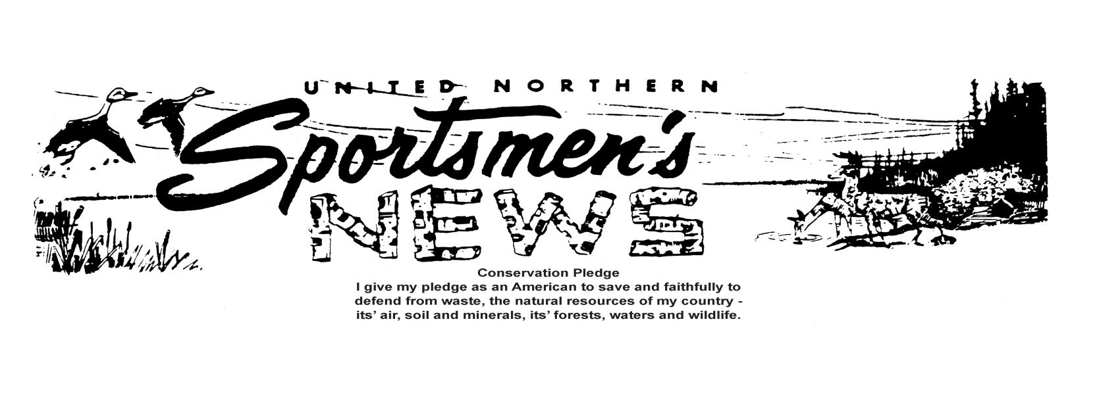

__________________________________________________________________________________________VOLUME 62 SEPTEMBER, 2017 NUMBER 9 $12.00
RANGE USE CALENDAR may be found on our Website: uns-duluth.com

Youth Outdoor Field Day/UNS Picnic

A
ugust 5th and August 12th were busy days at the retreat. August 5th was our UNS Picnic. We had a beautiful day and plenty of fun and food. Dana Dallum took the chairperson of this event this year and things went perfect for her, I didn’t hear any complaints about it and if there was I’m sure it was something minor. Thanks Dana and we hope you and your crew take it again next year too.
The following weekend we had our YOFD which had been in the planning for months. The Minnesota Deer Hunters (MDHA) and UNS put this on each year for our youth to try to keep them educated and interested in the outdoors and conservation. This year we had 70+ youths involved and each of them went through 8 different stations. These included: Black River Bandits, Black Powder, Large Bore, Small Bore, Archery, Trap Shooting, a Trapping Seminar and How to safely climb a Tree Stand. We also had a Conservation Officer, Andy Schmidt) who gave a presentation during lunch and then answered lots and lots of questions. We would like to thank Paul Pederson of the MDHA and Cody Privette and all of his crew from the UNS for a job well done.

Club Calendar

Sept. 6 UNS Board Meeting
Sportsmen’s Retreat
6:00 PM Pot Luck
7:00 PM Board Meeting
Work Party Prior to

Sept. 7 Application Deadline
Antlerless deer/special hunts

Sept. 13 UNS Membership Meeting
Sportsmen’s Retreat
6:00 PM Pot Luck
7:00 PM Membership Meeting
Work Party Prior to

Sept. 16 Small Game seasons open
Deer Archery season opens

Sept. 17 Early Canada Goose season closes

Sept 30 Fall turkey season opens
Lake trout (summer inland
Waters) closes
Stream trout (summer in
Streams) closes

(Club Notes continued from page 4)

Emailing of Newsletter – Duane Lasley & Others: Email list up to 370, savings of $.23 per newsletter that doesn’t need to be mailed.
Youth Field Day – Cody Privette: Gave overview of progress so far. Should be a great event this year.
Mike Drager: We have plenty of ammo for this year. We had to buy some ammo and had a lot donated. Thanks to Superior Shooters Supply and Marine General for their donations.
NEW BUSINESS:
Approve Donation to the SLC Sheriff’s Rescue Squad $250 – Tom Wasbotten: Motion by Dan Smestad 2nd by Duane Lasley to approve donation. Discussion followed about increasing donation amount. Carried.
Approve Fall Fund Raiser Budget Request $2000- Tina Sund & Deanna Dodge: Motion by Duane Lasley 2nd by Bob Klein to approve the budget. Discussion followed about what the budget is for. Carried.
Range Officer Refresher Training – September 30th 9am: Bob Kuettel gave overview of event.
MCF Resolutions – Sandy Roberts: We are asking for resolutions to be sent down to MCF. Motion by Mike Drager 2nd by Duane Lasley to support resolution to de-list the wolves from the endangered list. Discussion followed. Carried with 1 opposed.
Attendance Drawing: Gene Shaw won the $20.00
Progressive Drawing: Gerald Hendrickson was not present, therefore did not win $80.
Members sick or in distress: None Reported
Adjournment: Motion was made by Mike Foy, 2nd by Larry Chesney at 8:18 pm; Carried.
Respectfully submitted by Cody Privette, Secretary.
Next meetings will be the September BOD meeting on 9/6 and the Membership meeting on 9/13. Both will be at 7pm at the retreat.

Hunters should note errors in printed hunting regulations handbook and map
H
unters should be aware of several errors in printed copies of the 2017 Minnesota Hunting and Trapping Regulations Handbook and in the fold-out deer season map that accompanies the regulations booklet.

In the fold-out map, correct information is as follows:
- In central and northwestern Minnesota, deer permit areas (DPA) have 500 permits to harvest antlerless deer for DPA 197; 300 for DPA 262; 150 for DPA 269; 25 for DPA 270; 350 for DPA 271; 200 for DPA 272; and 100 for DPA 297.
- In 300 series permit areas, DPA 344 is designated as Hunters Choice; DPAs 341, 342, 343 and 347 are Managed; and DPA 346 is Intensive.
- The list of affected permit areas related to the section titled “Deer Permit Area Boundary Changes Along the Moose Range” should include DPAs 178 and 181.
- Permit area 340 under the Hunters Choice deer area heading doesn’t exist and should be deleted.
In the printed booklet, correct information is as follows:
- The special youth deer hunt schedule on page 36 should include information on a hunt at Blue Mounds State Park. Mention of the hunt on page 87 should be deleted. The hunt is being held Nov. 18 and 19. There are 10 permits available.
- The closing date for a proposed late season deer hunt on page 62 is Jan. 14.
- The list of permit areas for which the landowner licenses is valid on page 67 should include DPA 218.
- The bag limit is three for the special archery deer hunt in the city of New Ulm on page 93.
- The special firearms deer hunts list that begins on page 85 should include a special hunt at Zumbro Falls Scientific and Natural Area (SNA) in Wabasha County from Nov. 18-26. It is hunt number 923.
- Dates for the special firearms deer hunt at Vermillion Highlands Research, Recreation and WMA on page 86 should be Nov. 4-17.
- Firearms deer licenses for the A and B season are valid for the Carver Park Reserve special hunt on page 87.
- The Itasca State Park special hunt on page 85 has a bag limit of 3.

Club Notes August 9th, 2017
Call to Order: by President Tom Wasbotten@ 7:01 pm. Conservation Pledge.
Roll Call of Officers: Bob Kuettel, Tina Sund, Mike Drager, Mike Foy, Bob Klein, Dan Smestad, Larry Chesney, Duane Lasley, Sandy Roberts, Joe Roberts, Dave Shrader, Judy Foy, Tom Wasbotten, Eric Hansen, Gene Shaw and Cody Privette.
Excused Officers: John Bathke
New Members Present: Dana Dallum
Correspondence: NRA Traditions Quarterly and NSSF Shot Quarterly
Agenda Additions: Motion to approve the agenda with the new additions by Mike Foy 2nd by Eric Hansen; Carried.
Reading of Minutes: Cody Privette read minutes from the July Membership meeting. Motion to accept minutes as corrected by Sandy Roberts, 2nd by Judy Foy; Carried. Synopsis of Board of Directors minutes from August was also read.
Treasurer’s Report - Tina Sund: as of 7/31/17Bob Kuettel made a motion to accept the report and pay our bills, 2nd by Duane Lasley; Carried.
Membership Secretary’s Report- Sandy Roberts : Current membership is 1,652 members, $6,550 was deposited and 90 second notices were sent..
Committee Reports:
Web Master – Eric Hansen: Posted latest brass report and newsletter, and range reservations and updated the website.
Incident Reports – Mike Foy: Nothing new to report.
Retreat Improvements & Maintenance – Dave Shrader: Sorted brass, mowed rifle range and tree nursery, cleared and sprayed the property line fence, cut lilac bushes with Cody and Kathleen, loaded and hauled junk to dump, fixed shower and changed locks on meter box.
Joe Roberts: Gave and overview of the Liberty Safe lock issue. The safe is now usable.
Bob Kuettel: Gave overview of the phone system needs and update costs.
Grants Committee - Mike Drager: Nothing new to share.
Volunteer Awards – Dan Smestad: Duane Lasley 400+ Hours.
Facilities Calendar – Bob Kuettel: Youth Field Day August 12th all ranges closed. Border Patrol has the rifle range reserved on the 21st and 22nd. Jerry Siedlecki has the pistol range reserved on the 15th and 29th.
Budget & Finance Report – Mike Drager: Nothing new.
OLD BUSINESS:
Summer Picnic – Dana Dallum: Great event this year. 128 total people, seems to be about average. 21 people volunteered. A few new events this year. Discussion followed about volunteer hours for committee chairs.
Tom Wasbotten: On behalf of the club, thank you for all your hard work and preparation. Survey Committee Report – Duane Lasley: Have a bunch of hard copies that need to be manually entered.
(Club Notes continued on page 3)
UNITED NORTHERN SPORTSMEN’S NEWS
2016 EXECITIVE BOARD
Editor: Joe Roberts
234 E. Orange St., Duluth, MN 55811, 218-722-2711
www.uns-duluth.com e-mail: unsclub@gmail.com
Webmaster: Eric Hansen
4182 Ridge Circle, Hermantown, MN 55811, 218- 831-8646
OFFICERS:
President: Tom Wasbotten
5472 Island Lake Road, Duluth, MN 55803, 218-721-4864
Vice-President: Bob Kuettel
214 Bluffs Ridge Court, Duluth, MN 55811, 218-724-5823
Secretary: Cody Privette
331 N. 63rd Ave. W., Duluth, MN 55807, 218-260-2932
Treasurer: Tina Sund
3520 Stebner Road, Hermantown, MN 55811, 218-591-3304
Sgt-at-Arms: Duane Lasley
4501 Otsego St., Duluth, MN 55804, 218-310-4273
Membership Secretary: Sandy Roberts
234 E. Orange St., Duluth, MN 55811, 218-722-2711
TRUSTEES:
Larry Chesney
6363 Beaver River Rd., Duluth, MN 55803, 218-349-4426
John Bathke
P.O. Box 86, Two Harbors, MN 55616, 218-834-7075
Dave Shrader
5057 W. Arrowhead Road, Duluth, MN 55811, 218-576-3011
Dan Smestad
4136 Kingston Road, Duluth, MN, 55803, 218-525-3669
Eric Hansen
4182 Ridge Circle, Hermantown, MN 55811, 218-831-8646
Mike Drager
6657 Brookmere Road, Duluth, MN 55803, 218-721-3214
Judy Foy
5 W. 8th St., Duluth, MN 55806, 218-591-2391
Bob Klein
4612 Jay St., Duluth, MN 558-04, 218-525-6468
Gene Shaw
5219 Kingswood Lane, Hermantown, MN 55811, 218-348-2191
United Northern Sportsmen
Editor: Joe Roberts
234 E. Orange St.
Duluth, MN 55811-2955
RETURN SERVICE REQUESTED
PRSRT STD
US Postage
PAID
Permit 49
Duluth, MN

